AI Soil fertility Enhancer
Akshatha P R 24N201
Jai Krishikaa V J 24N217
Praneeth V 24N238
Ram Kaushik A 24N243
Surya S 24N257
Thanga Lakshmi N 24N259
Haya 25N431

23N315 - AICTE ACTIVITY POINT PROGRAMME
report submitted in partial fulfillment of the requirements for the award of degree of

BACHELOR OF ENGINEERING
Branch: COMPUTER SCIENCE AND ENGINEERING(AIML)
Of Anna University


December 2025
DEPARTMENT OF COMPUTER SCIENCE AND ENGINEERING
PSG COLLEGE OF TECHNOLOGY
(Autonomous Institution)
COIMBATORE – 641 004
PSG COLLEGE OF TECHNOLOGY
(Autonomous Institution)
COIMBATORE – 641 004
AI Soil fertility Enhancer
Bona fide record of work done by
Akshatha P R 24N201
Jai Krishikaa V J 24N217
Praneeth V 24N238
Ram Kaushik A 24N243
Surya S 24N257
Thanga Lakshmi N 24N259
Hayaa 25N431

Dissertation submitted in partial fulfillment of the requirements for the degree of
BACHELOR OF ENGINEERING
Branch: COMPUTER SCIENCE AND ENGINEERING
of Anna University
DECEMBER 2025
Mr. Prakash J
Mentor/Tutor
BE-CSE (AI & ML)

Dr. G R Karpagam Dr.G.SudhaSadasivam
Programme Coordinator Head of the Department
BE-CSE (AI & ML) CSE

ACKNOWLEDGEMENT

The AICTE Activity Point Programme project work had paved the way for personal development and creativity as proud volunteers with a sense of achievement and ready to take up projects having a social impact and creating digital awareness. We feel privileged to be associated with such a curriculum in PSG College of Technology.
We are extremely grateful to our Principal Dr.K.Prakasan for facilitating and extending untiring support in successful completion of the project. We are extremely glad to extend our gratitude to the department Head Dr. G. Sudha Sadhasivam and Programme Co-Ordinator Dr. G. R. Karpagam for offering us this opportunity which has made us to strengthen our soft skills, leadership qualities and team spirit. We extend our thanks to Department Placement Co-Ordinator Dr.K.Sathiya Priya who has been the pillar of support.
We would like to take this opportunity to place my sincere thanks to our Tutor Mr. Prakash J for his guidance in our project work and would also like to thank our Panel members who has spent their valuable time to aid us for coming out with the good project.
We would like to place our sincere thanks to the management for offering us this opportunity and they have rendered their utmost support and made us aware of social issues that gave us the vision to have societal commitment leading to community service.

CERTIFICATE
Certified that this report titled “AI SOIL FERTILITY ENHACER ” for the AICTE ACTIVITY POINT PROGRAMME project work (23N315) is a Bonafide work of “Akshatha P R (24N201), Jai Krishikaa V J (24N217), Praneeth V (24N238), Ram Kaushik A (24N243), Surya S (24N257), Thanga Lakshmi N (24N259), Haya (25N431) ” who have carried out the work for the partial fulfillment of the requirements for the award of the degree of Bachelor of Engineering in Computer Science and Engineering.

Place: Coimbatore
Date : 22.12.2025

Tutor Department Placement Coordinator
Mr.Prakash J Dr. K SATHIYA PRIYA

COUNTERSIGNED

Dr.G.Sudha Sadasivam
HEAD
Department of Computer Science and Engineering
PSG College of Technology, Coimbatore – 641004

CONTENTS
CHAPTER Page No.
ABSTRACT 1
1. INTRODUCTION 2
1.1 Need for a Smart Agricultural Solution
1.2 Alignment with AICTE & Sustainable Development Goals
2. RELATED STUDY 3
2.1 IoT-Based Soil Monitoring Systems
2.2 AI and Machine Learning Applications in Agriculture
2.3 Limitations of Existing Systems
2.4 Importance of Sustainability
3. FEASIBILITY ANALYSIS 5
3.1 Technical Feasibility
3.2 Economic Feasibility
3.3 Operational Feasibility
3.4 Social Feasibility
3.5 Environmental Feasibility
3.6 Legal and Ethical Feasibility

4. REQUIREMENT ANALYSIS 7
4.1 Functional Requirements
4.1.1 User Management and Authentication
4.1.2 IoT Device Management (Software Side)
4.1.3 Soil Analysis and Monitoring
4.1.4 AI Recommendations and Decision Support
4.1.5 Notifications and Support Services
4.1.6 Feedback loop
4.2 Non – Functional Requirements
4.2.1 Usability and Accessibility
4.2.2 Reliability and Availability
4.2.3 Performance and Scalability
4.2.4 Security
4.2.5 Interoperability
5. DESIGN/PROTOTYPE 12
6. TIME LINE ACTIVITY 15
7. CONCLUSION 16
8. REFERENCE 17

ABSTRACT

This abstract describes a cutting-edge AI-powered method that uses hyper-localized intelligence and real-time environmental feeds to optimize crop care and soil fertility. For real-time feeds of vital soil parameters (NPK, Ph, moisture, organic matter) and microclimate parameters (temperature, humidity, light intensity), the system uses a vast IoT sensor network spread throughout the farm. The raw feed is then fed into advanced machine learning models that combine real-time weather alerts from official meteorological broadcasts with broader climate change trends, in addition to processing historical and present farm-specific data.

With the help of this hybrid solution, the AI can produce dynamic, extremely precise fertilizer recommendations, including the best times to apply a given nutrient blend, amount, and blend for specific farm regions. A specialized interface (such as a web portal or mobile app) provides farmers with regular, streamlined reports and practical recommendations. The goal of this solution is to greatly improve agricultural climate change resilience, lower input costs, lessen the impact on the environment, and eventually increase sustainable crop yields by integrating sensor data from the ground level and macro-level climate data.

CHAPTER – 1
INTRODUCTION
Agriculture is still the main source of income for millions of rural families in India. However, many farmers continue to depend on traditional knowledge for managing soil fertility and selecting the right crops. This reliance on inherited methods often results in low productivity, wasteful use of fertilizers, and frequent financial setbacks. A key reason for this problem is the lack of access to affordable and accurate soil testing services. Manual soil testing can be too expensive or unavailable in remote areas, creating a significant gap between modern scientific approaches and rural farming practices. Without proper knowledge of soil health, farmers often make decisions based on guesswork. This leads to poor crop yields and long-term soil damage.
1.1 Need for a Smart Agricultural Solution
To close this gap, we need a smart and affordable solution. This solution should integrate technology into traditional farming systems without making the process complicated for rural farmers. The proposed project provides such a solution by using IoT-based soil sensors to gather key soil information, along with an AI model to interpret these readings. This approach offers accurate soil assessments and personalized crop recommendations that farmers can easily understand and apply. The system is designed for simplicity, ensuring that even farmers with limited technical skills can benefit from it.
1.2 Alignment with AICTE & Sustainable Development Goals
This project closely aligns with the goals of the AICTE Internship Policy, which encourages rural development, digital literacy, and the adoption of modern technology to enhance quality of life. It also directly supports several United Nations Sustainable Development Goals (SDGs), including Zero Hunger (SDG 2), Quality Education (SDG 4), Responsible Consumption and Production (SDG 12), and Economic Growth (SDG 8). By giving farmers reliable scientific information, this project promotes sustainable agricultural practices and long-term rural empowerment.

CHAPTER – 2
RELATED STUDY
Modern agricultural research emphasizes the integration of sensor technology and artificial intelligence to improve crop productivity and optimize resource usage. Real-time soil data has been shown to support better decision-making and reduce excessive use of fertilizers and water. The combination of IoT and AI is therefore considered an effective solution to challenges in traditional farming.

2.1 IoT-Based Soil Monitoring Systems
Advancements in sensor technology enable real-time measurement of key soil parameters such as moisture content, pH level, temperature, and NPK nutrient concentration. Capacitive moisture sensors, electrochemical pH sensors, and NPK sensors provide continuous and cost-effective monitoring. IoT-based soil monitoring systems reduce the need for repeated manual soil testing and allow farmers to observe soil conditions throughout the crop lifecycle.

2.2 AI and Machine Learning Applications in Agriculture
Artificial Intelligence has significantly influenced modern agriculture. Machine learning algorithms such as Support Vector Machines, Random Forests, K-Nearest Neighbors, and Neural Networks are widely used for crop recommendation, yield prediction, disease detection, and irrigation planning. These data-driven approaches improve accuracy, reduce human error, and enhance overall farming efficiency.

2.3 Limitations of Existing Systems
Many existing agricultural advisory systems are not integrated with real-time soil sensing hardware. Several solutions are costly, complex, and difficult for rural farmers to use. Limited local language support and lack of personalized recommendations reduce their effectiveness. These limitations highlight the need for a simple, affordable, and localized system combining both IoT sensors and AI models.

2.4 Importance of Sustainability
Sustainable farming practices are essential for maintaining soil health and long-term agricultural productivity. Continuous soil monitoring and optimized nutrient management help increase crop yield while minimizing environmental impact. Integrating AI and IoT for soil analysis supports sustainable agriculture by addressing both technological and environmental concerns.

CHAPTER – 3
FEASIBILITY ANALYSIS
A feasibility study is crucial to assess whether the proposed system can be developed, implemented, and effectively used in rural areas. This includes evaluating its technical, economic, operational, social, environmental, and legal viability.
3.1 Technical Feasibility
The project is technically feasible due to the availability of low-cost IoT components and open-source AI tools. Sensors that measure soil Ph, temperature, moisture, and nutrient levels can be easily connected to microcontrollers like Arduino or ESP32. These devices send data to the AI model, which nalyses it and generates useful crop recommendations. The modular design and strong community support ensure that the system can be assembled, run, and maintained without needing high technical expertise.
3.2 Economic Feasibility
From an economic standpoint, the project is both affordable and cost-effective. The components involved—like sensors, microcontrollers, and communication modules—are inexpensive and widely available. Using open-source platforms keeps software costs low. The long-term savings for farmers come from reduced input costs and improved crop yields, making the system financially appealing. Community-based deployment further lowers individual expenses.
3.3 Operational Feasibility
Operationally, the system is straightforward to use and tailored for rural settings. The user interface can be adapted to local languages, and the instructions are clear. Once set up, the system requires minimal user input, making it suitable for farmers with limited technical background. Additionally, local youth can be trained to manage the system, creating job opportunities and ensuring smooth operation.

3.4 Social Feasibility
The project is socially acceptable and advantageous as it directly enhances agricultural productivity and supports rural livelihoods. Farmers gain confidence in their crop decisions, young people learn new technical skills, and communities benefit from better soil management and reduced financial risks. The project also builds trust by presenting scientific information in a straightforward and accessible manner.
3.5 Environmental Feasibility
The project’s environmental feasibility is robust, as it encourages sustainable farming practices. By preventing excess fertilizer use and optimizing resource consumption, the system helps protect soil fertility and reduce pollution. Accurate monitoring also aids long-term soil conservation, making agriculture more environmentally friendly.
3.6 Legal and Ethical Feasibility
The project complies with current agricultural and technological laws. Since the data collected by the sensors does not include personal information, there are no privacy issues. Utilizing open-source tools and standard hardware ensures that the system respects intellectual property rights. Hence, the project is both legally and ethically sound.

CHAPTER – 4
REQUIREMENT ANALYSIS
4.1 Functional Requirements (FR)
Functional requirements define the core features, behaviors, and operations that the proposed software system must support to meet user and system needs. The system is designed to assist farmers in monitoring soil health, managing IoT devices, and receiving intelligent, data-driven agricultural recommendations.
4.1.1 User Management and Authentication
- User Registration: The system shall allow farmers to create a user account by providing essential details such as Full Name, Email Address, Password, and Phone Number. The system must validate user inputs and ensure secure storage of credentials.
- User Authentication: The system shall provide a secure login mechanism using a Username (or Email) and Password. It must support a “Remember Me” option to maintain user sessions across multiple logins while ensuring security.
- Password Recovery: The system shall include a “Forgot Password” feature that allows users to reset their credentials through a secure verification process using Email or SMS-based OTP authentication.
- Profile Management: The system shall allow users to view, update, and manage their profile information, including personal details and farm-related information, to ensure personalized recommendations.
4.1.2 IoT Device Management (Software Side)
- Device Registration and Listing: The system shall allow users to register and associate multiple IoT devices (e.g., soil sensor nodes) with their farm. The application must display a structured list of devices such as Device 1, Device 2, etc.
- Real-Time Device Status Monitoring: The system shall continuously monitor and display the operational status of each device, indicating states such as Active, Offline, or Error, to help users quickly identify malfunctioning sensors.
- Data Ingestion API: The backend system shall expose secure API endpoints to receive real-time raw sensor data including pH, NPK values (Nitrogen, Phosphorus, Potassium), soil moisture, and temperature transmitted by external IoT hardware.
- Error Detection: The system shall identify abnormal or missing data from sensors and flag potential hardware or communication failures.
4.1.3 Soil Analysis and Monitoring
- Real-Time Data Visualization: The Soil Condition module shall display live sensor readings such as NPK levels, pH value, soil moisture, and temperature using graphs, charts, or dashboards for easy interpretation.
- Historical Data Storage: The system shall store time-stamped historical soil sensor data in a database, enabling long-term analysis and performance comparison.
- Trend Analysis: The system shall allow users to analyze historical data trends to understand changes in soil health over different time periods and seasons.
4.1.4 AI Recommendations and Decision Support
- Crop Recommendation System: The system shall use Machine Learning models such as Random Forest to analyze soil parameters, historical data, and weather conditions to recommend the most suitable crops for a specific farm.
- Fertilizer Advisory System: Based on soil nutrient deficiencies and crop requirements, the system shall generate precise fertilizer recommendations, including nutrient composition, quantity, and optimal application timing.
- Weather Data Integration: The system shall integrate with external weather APIs such as IMD and NASA POWER to fetch real-time weather data, forecasts, and alerts relevant to the farm’s geographical location.
- Decision Support Insights: The system shall provide actionable insights combining soil data, weather patterns, and AI predictions to support informed agricultural decision-making.
4.1.5 Notifications and Support Services
- Alert and Notification System: The system shall send push notifications or SMS alerts to users for critical conditions such as low soil moisture, extreme weather events, abnormal soil parameters, or device malfunctions.
- Help and Educational Resources: The application shall include a Help section containing tutorials, guides, FAQs, and training modules to educate farmers on soil health, sensor usage, and interpretation of recommendations.
4.1.6 Feedback Loop
- User Feedback Mechanism: The system shall allow farmers to submit feedback by reporting actual crop yields, fertilizer usage, and outcomes compared to AI predictions.

4.2 Non-Functional Requirements NFR
Non-functional requirements define the quality attributes, performance standards, security constraints, and overall user experience expectations of the system. These requirements ensure that the application is reliable, secure, scalable, and usable, especially in rural and low-connectivity environments.
4.2.1 Usability and Accessibility
- Localization and Language Support: The application must support multiple languages, specifically Tamil and English, to ensure ease of use for rural farmers and users with varying literacy levels. The system should allow users to switch languages seamlessly from within the application.
- Simple and Intuitive UI/UX: The user interface must be clean, intuitive, and visually driven, using graphs, charts, icons, and color indicators instead of complex text. Navigation should be minimal and self-explanatory to support users with limited digital literacy.
- Accessibility Considerations: The system should use readable font sizes, clear contrast, and simple layouts to ensure accessibility for elderly users and those with visual limitations.
- Response Time: Key mobile application screens such as Login, Dashboard, and Soil Monitoring pages should load within 2 to 3 seconds under normal network conditions to ensure a smooth user experience.
4.2.2 Reliability and Availability
- Offline Functionality: The mobile application must support offline usage in regions with low or unstable internet connectivity. It should cache the most recent sensor data, recommendations, and alerts locally and automatically synchronize with the cloud server once connectivity is restored.
- System Availability: The backend services should be designed to maintain high availability with minimal downtime to ensure continuous access to soil data and alerts.
- Fault Tolerance: In the event of sensor malfunction, corrupt data transmission, or hardware failure (indicated by an Error or Offline status), the system must handle the situation gracefully without crashing and should notify the user appropriately.

4.2.3 Performance and Scalability
- Scalability: The cloud backend must be designed using scalable architecture principles to support a growing number of registered farmers, IoT devices, and concurrent users as the system expands across regions.
- Data Processing Efficiency: The system should efficiently process incoming sensor data streams without performance degradation, even during peak usage periods.
- Data Latency: Real-time sensor readings should be processed, stored, and reflected on the user dashboard with a latency of no more than 60 seconds from the time of data transmission by the hardware device.
4.2.4 Security
- Data Privacy and Protection: All sensitive user data such as names, phone numbers, login credentials, and farm details must be securely stored using encryption techniques in the database to prevent unauthorized access.
- Secure Authentication: User authentication mechanisms should follow secure practices such as hashed passwords and session management to protect user accounts.
- API Security: Communication between external IoT hardware and the backend server must be secured using mechanisms such as API keys, access tokens, or secure authentication protocols to prevent unauthorized data injection or tampering.
4.2.5 Interoperability
- External System Integration: The system should be designed with interoperability in mind to allow future integration with government or third-party agricultural platforms such as the Soil Health Card Scheme or the Uzhavan App.
- Standardized Data Formats: The application should use standardized data formats and APIs to ensure smooth data exchange with external systems and services in the future.

CHAPTER – 5
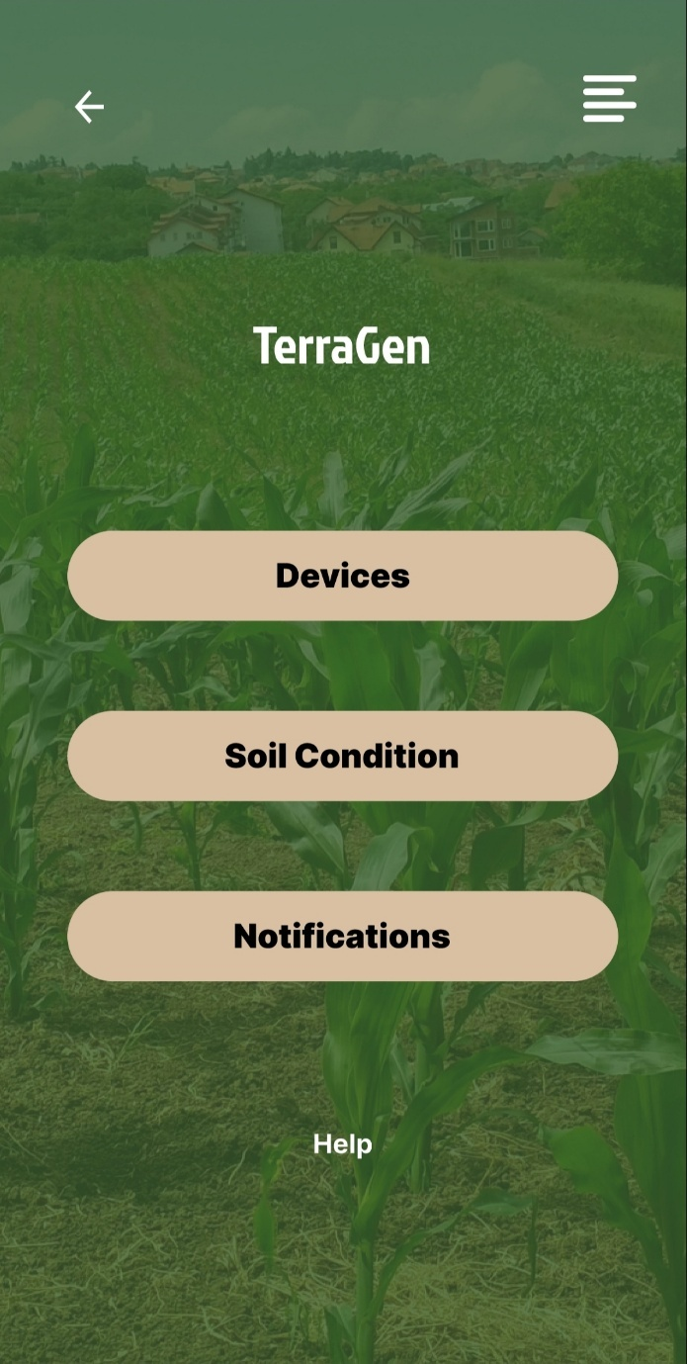
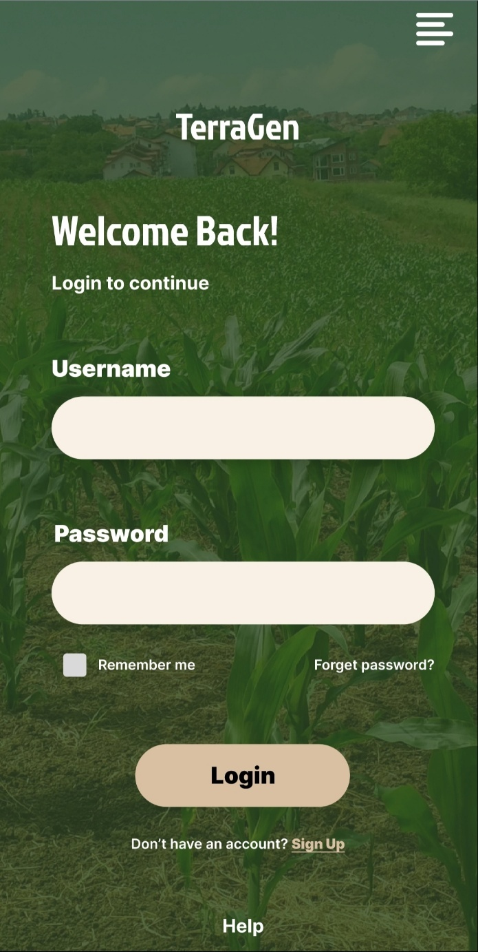
DESIGN/PROTOTYPE

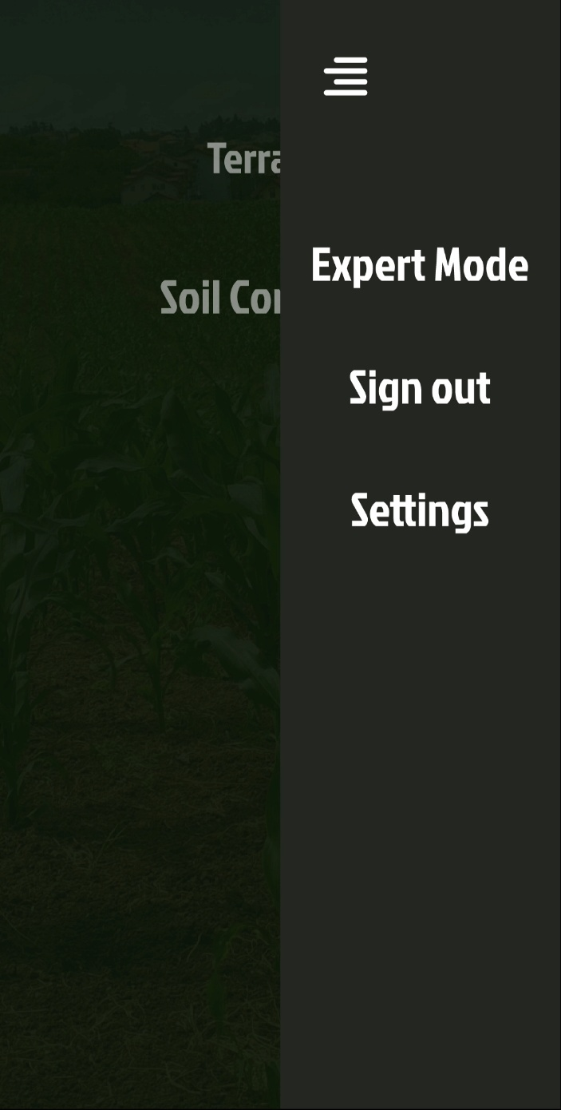
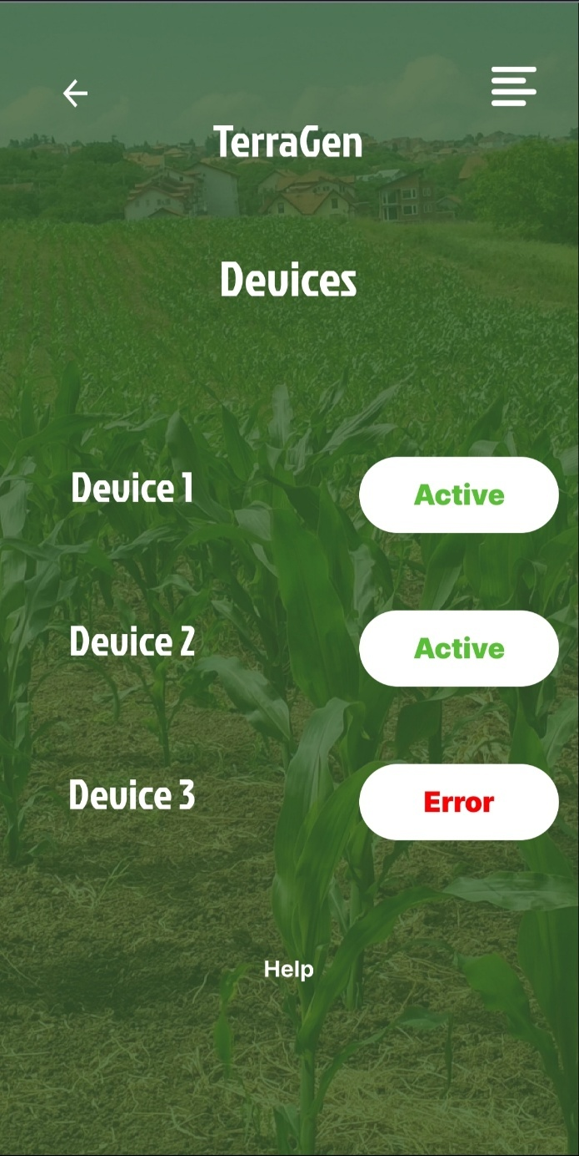

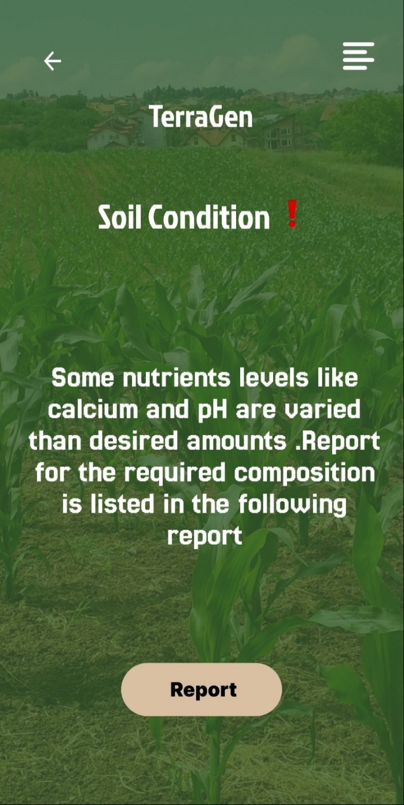
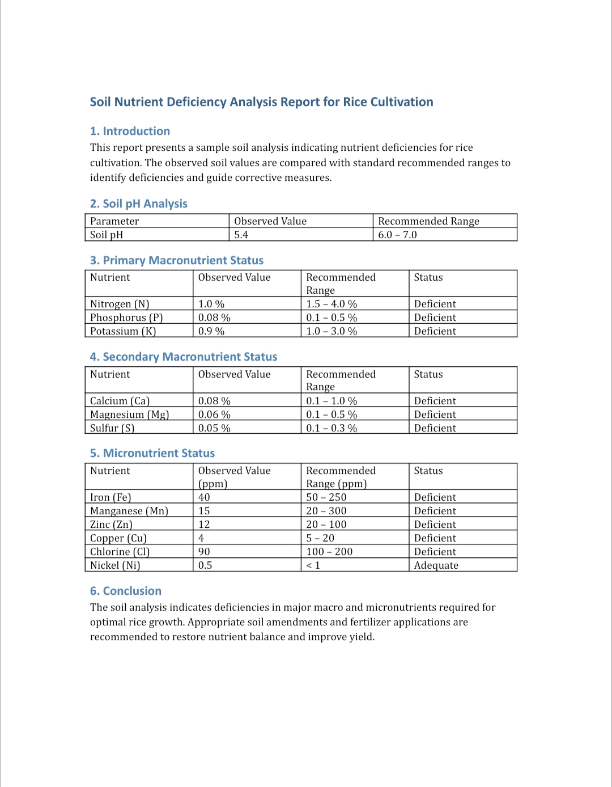

CHAPTER – 6
TIME LINE ACTIVITY

S. No | Activity list | Date/s of activity completed | No. of hours spent
1 | Data Source Identification & Data Collection | 09 AUGUST 2025 | 4 hrs.
2 | Data Integration & Data Cleaning & Preprocessing | 24 AUGUST 2025 | 4 hrs.
3 | Domain Understanding & Agricultural Analysis | 28-29 AUGUST 2025 | 5 hrs.
4 | Stakeholder & User Requirement Analysis | 10-11 SEPTEMBER 2025 | 4 hrs.
5 | Exploratory Data Analysis (EDA) | 27 SEPTEMBER 2025 | 6 hrs.
6 | Feature Engineering & Selection | 10-13 OCTOBER 2025 | 6 hrs.
7 | Dataset Preparation | 18 OCTOBER 2025 | 4 hrs.
8 | Model Selection , Model Training & Optimization (PART -1) | 21-24 OCTOBER 2025 | 8 hrs.
9 | Model Selection , Model Training & Optimization (PART -2) | 28-31 OCTOBER 2025 | 8 hrs.
10 | Model Evaluation & Validation (PART -1) | 6-8 NOVEMBER 2025 | 8 hrs.
11 | Model Evaluation & Validation (PART -2) | 14-15 NOVEMBER 2025 | 7 hrs
12 | Model Finalization & Documentation | 20-21 NOVEMBER 2025 | 8 hrs.
13 | Validation with Agricultural Guidelines | 25 NOVEMBER 2025 | 4 hrs.
14 | Risk Assessment , Mitigation & Ethical & Sustainability Assessment | 29 NOVEMBER 2025 | 4 hrs.

CHAPTER – 7
CONCLUSION

Agriculture continues to play a vital role in the livelihood of millions of people in India, especially in rural regions. However, the challenges faced by farmers due to limited access to scientific soil testing, unpredictable weather conditions, and improper crop selection often result in reduced productivity and financial losses. The proposed smart agricultural system effectively addresses these issues by integrating modern technologies with traditional farming practices in a simple and affordable manner.

By combining IoT-based soil sensors with artificial intelligence and machine learning models, the system provides accurate soil analysis and personalized crop and fertilizer recommendations. This approach reduces dependency on guesswork and promotes informed decision-making among farmers. The inclusion of real-time monitoring, historical data analysis, and weather integration further enhances the reliability and usefulness of the system throughout the farming cycle.

The feasibility analysis demonstrates that the system is technically achievable, economically affordable, operationally simple, socially acceptable, and environmentally sustainable. Its modular design, low-cost components, and use of open-source tools make it suitable for deployment in rural areas. Additionally, multilingual support and a user-friendly mobile interface ensure accessibility even for farmers with limited digital literacy.

Overall, this project bridges the gap between modern agricultural research and rural farming communities. It empowers farmers with scientific knowledge, encourages sustainable farming practices, and supports long-term soil conservation. By aligning with AICTE objectives and United Nations Sustainable Development Goals, the proposed solution contributes meaningfully to rural development, food security, and economic growth, making it a practical and impactful step toward smarter and more sustainable agriculture.

CHAPTER – 8
REFERENCE
1.What can artificial intelligence do for soil health in agriculture?
Author links open overlay panelStefan Schweng ª, Luca Bernardini ^{b} ^{c}, Katharina Keiblinger ^{b}, Hans-Peter Kaul ^{c}, Iztok Fister Jr. ^{d}, Niko Lukač ^{d}, Javier Del Ser ^{e} ^{f}, Andreas Holzinger; Computer Science Review
Volume 59, February 2026, 100832

2. Real-time soil fertility analysis, crop prediction, and insights using machine learning and deep learning algorithms
Kanimozhi Gunasekaran , Karmel A.^{2*}Pemmareddy Sreevardhan, ORIGINAL RESEARCH article
Front. Soil Sci., 31 October 2025
Sec. Soil Management
- Volume 5 - 2025
- Centre for Smart Grid Technologies, Vellore Institute of Technology, Chennai, India
- ²School of Computer Science and Engineering, Vellore Institute of Technology, Chennai, India

3. Hybrid AI Model for Soil Fertility Prediction and Fertilizer Optimization Madhan S1*, Thiyagu S2, Harirajan K3, Mohamed A4 1*Department of Computer Science & Engineering, University College of Engineering Thirukkuvalai, Nagapattinam, TN 610204, India, madhan444@gmail.coom 2,3,4Department of Computer Science & Engineering, University College of Engineering Thirukkuvalai, Nagapattinam, TN 610204, India,

4. Bioresour Bioprocess
. 2023 Dec 7;10(1):90. doi: 10.1186/s40643-023-00710-y
AI and machine learning for soil analysis: an assessment of sustainable agricultural practices
Muhammad Awais ^{1,2}, Syed Muhammad Zaigham Abbas Naqvi ^{1,2}, Hao Zhang ^{1,2}, Linze Li ^{1,2}, Wei Zhang ^{1,2}, Fuad A Awwad ³, Emad A A Ismail ³, M Ijaz Khan ^{4,5}, Vijaya Raghavan ⁶, Jiandong Hu ^{1,2,}

5. PLANT SCIENCE TODAY Vol 12(3): 1-14 https://doi.org/10.14719/pst.6669 eISSN 2348-1900 REVIEW ARTICLE Emerging trends in AI-based soil health assessment: A review Gayathri P1, Muthumanickam D1*, Pazhanivelan S2 , Kumaraperumal R1 , Kannan P2 & Prabu PC2 1Department of Remote Sensing and GIS, Tamil Nadu Agricultural University, Coimbatore 641 003, Tamil Nadu, India 2Centre for Water and Geospatial Studies, Tamil Nadu Agricultural University, Coimbatore 641 003, Tamil Nadu, India

